Page 1
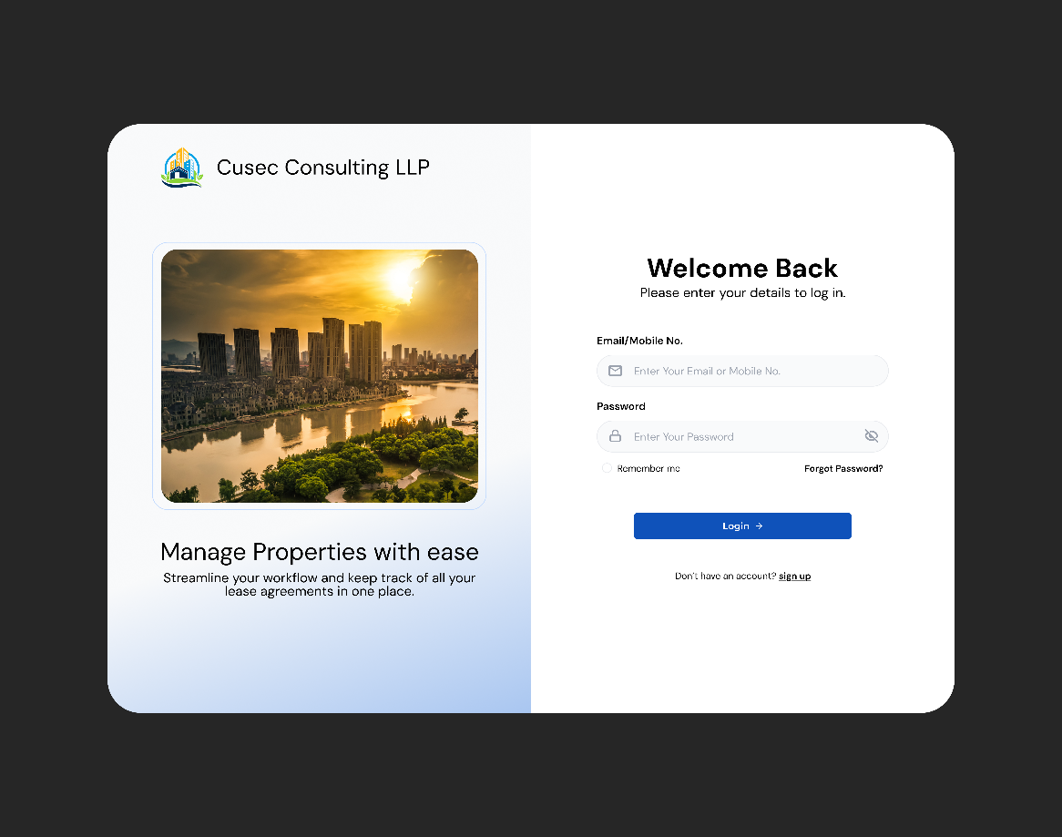
Page 2
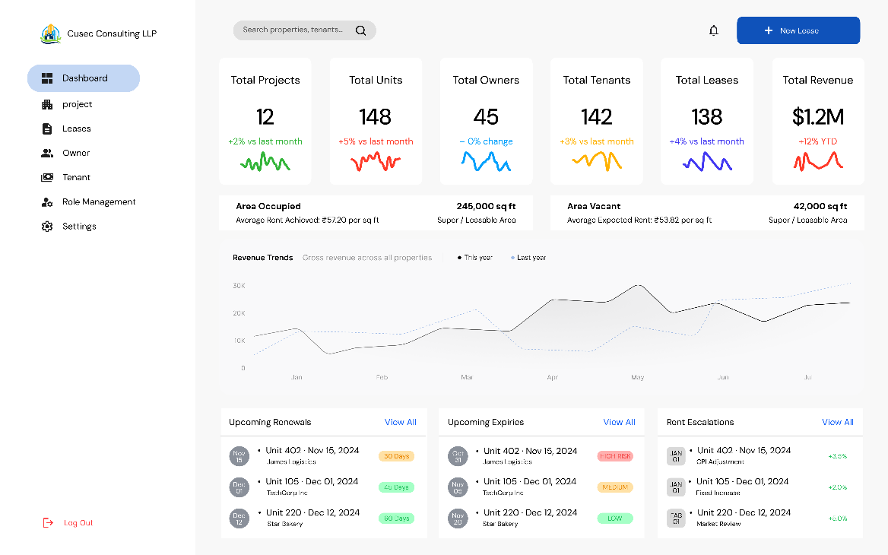

Page 3
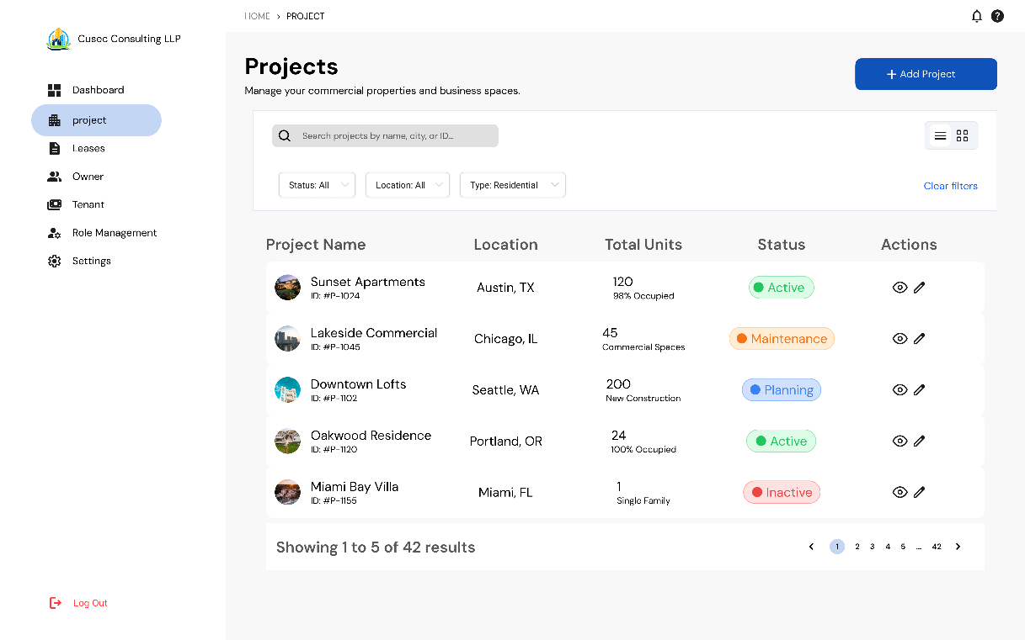
- What is the understanding of Active/Maintenance/Planning against the Projects

Page 4
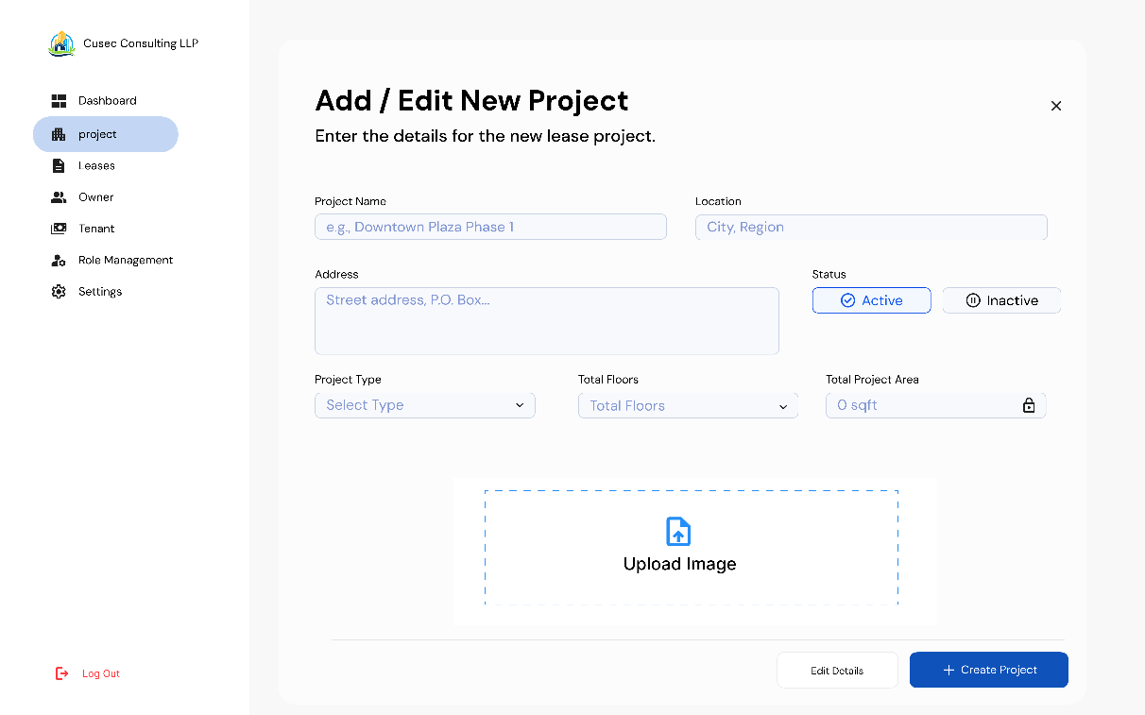

Page 5
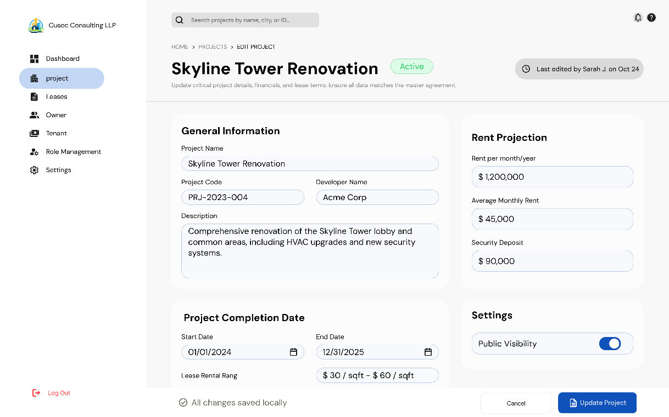

Page 5
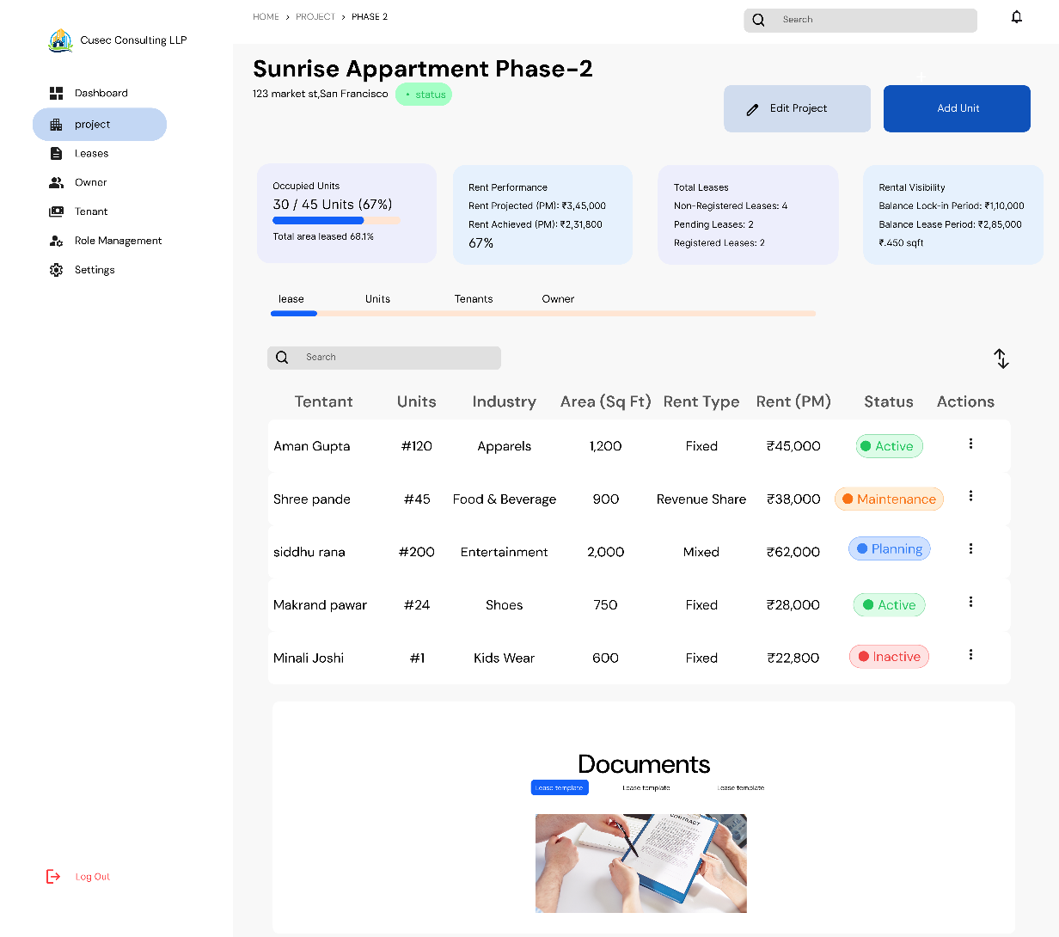
- I am not sure where the rentals coming out of calculation of Revenue Share shall be punched or recorded
Page 6
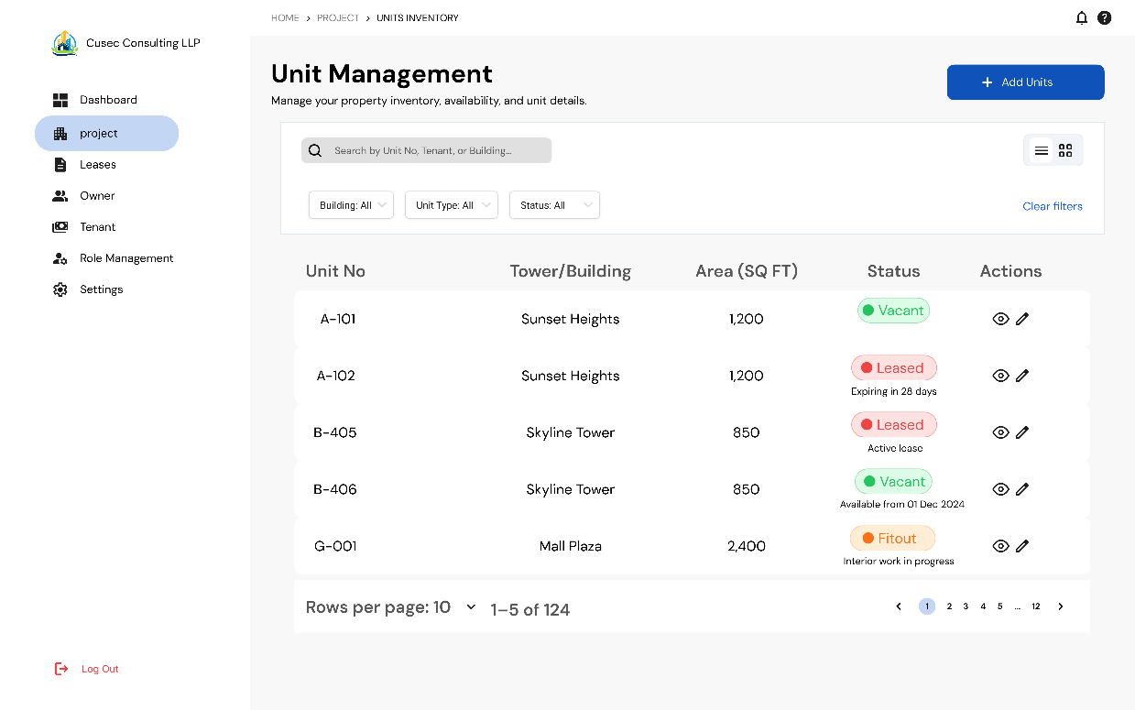
Page 7
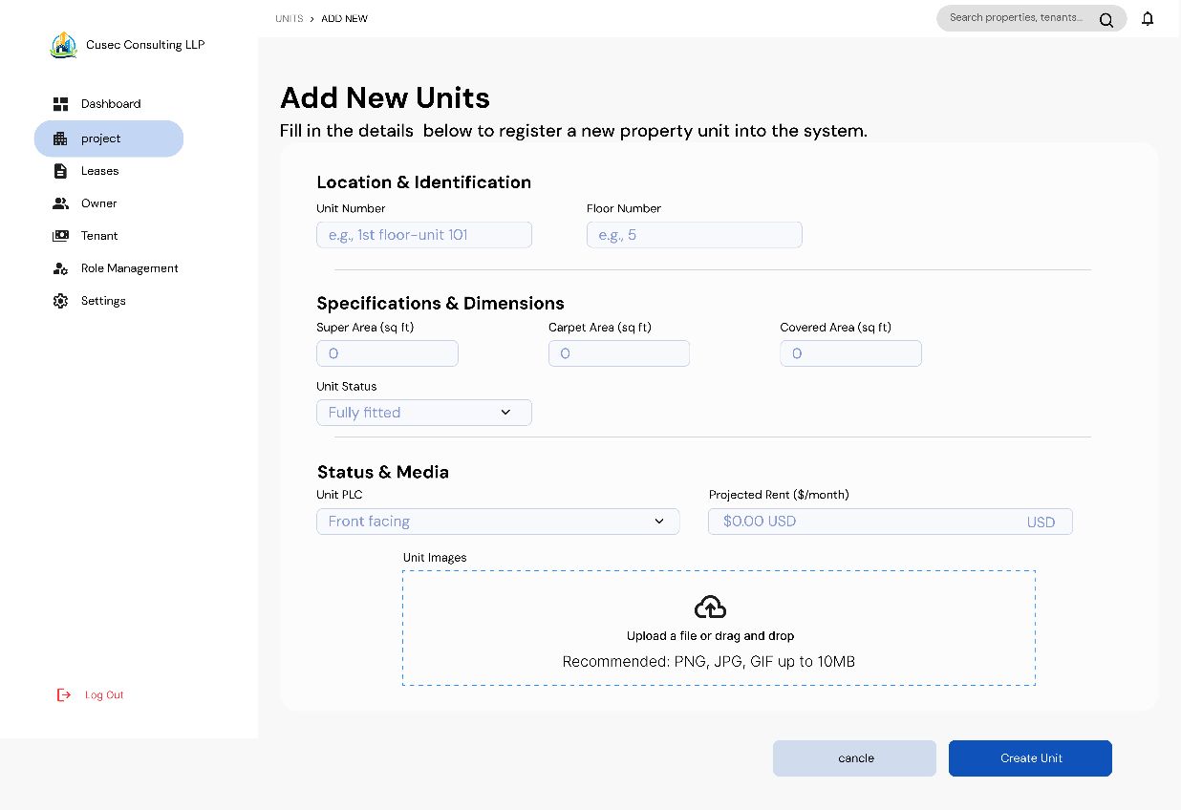
- Structure of Units is still not standard, lets discuss this.

Page 8
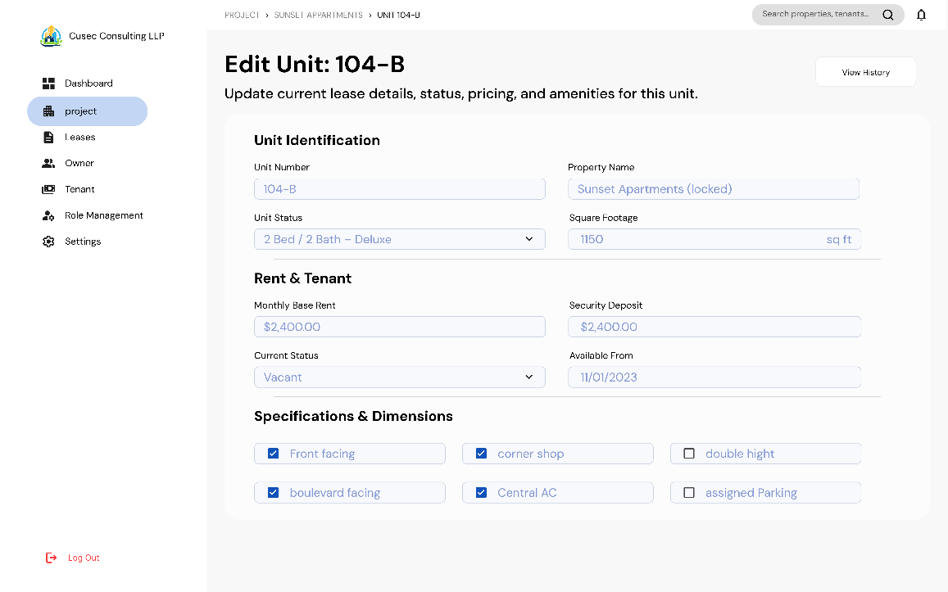
Page 9
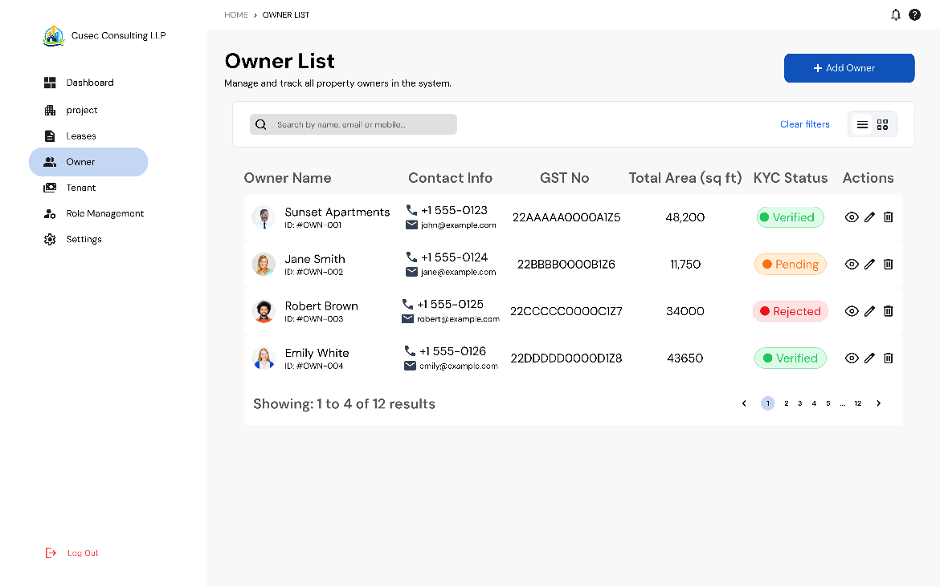

Page 10
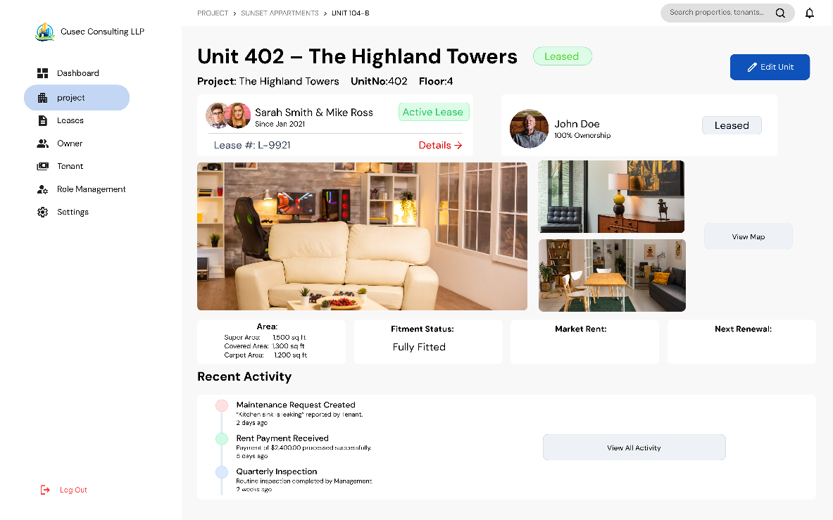
Page 11
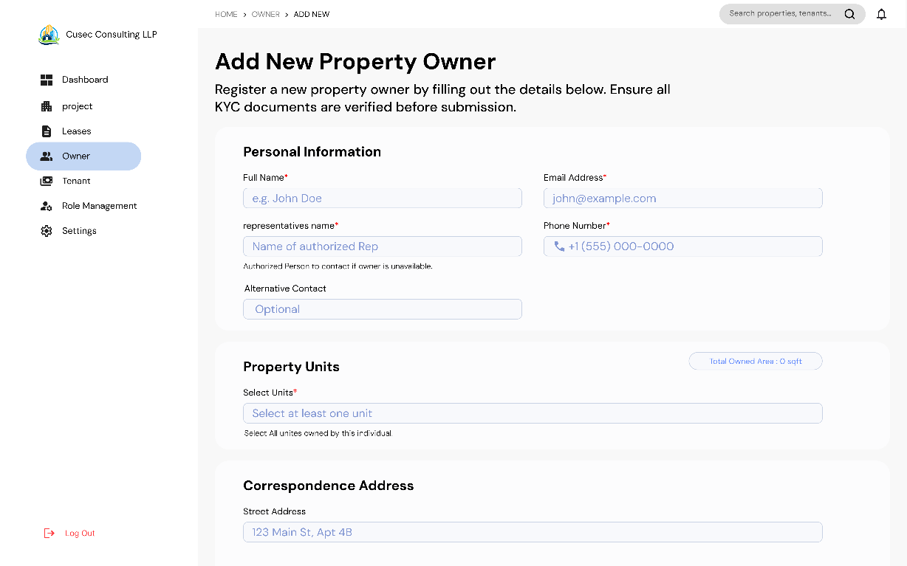
- Contact number and email is of Owner of Representative is not clear

Page 12
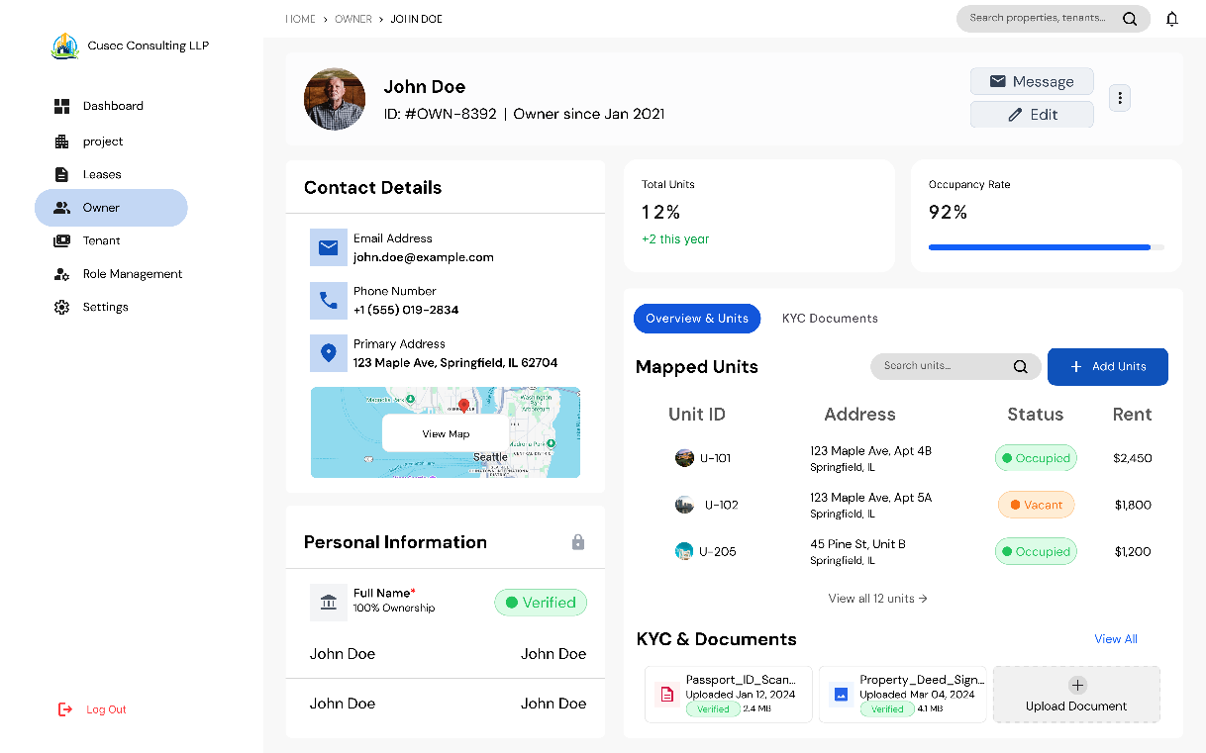
Page 13
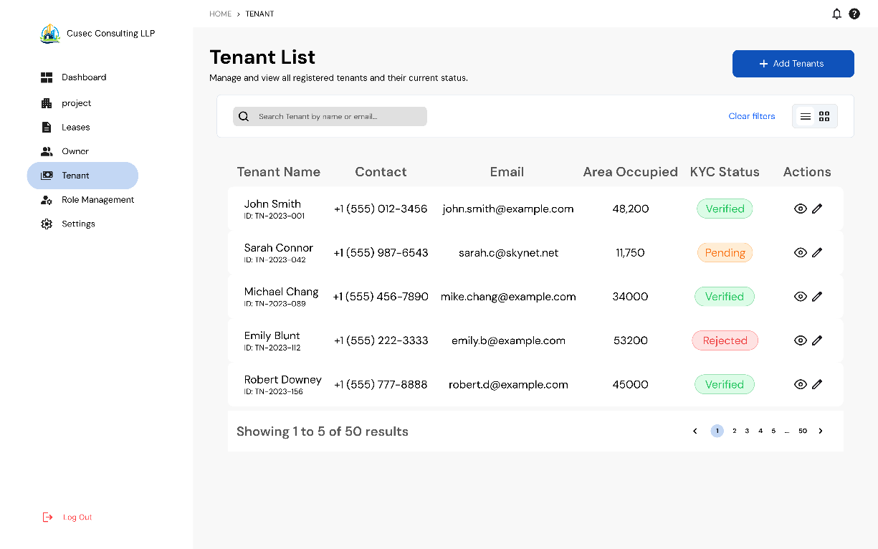

Page 14
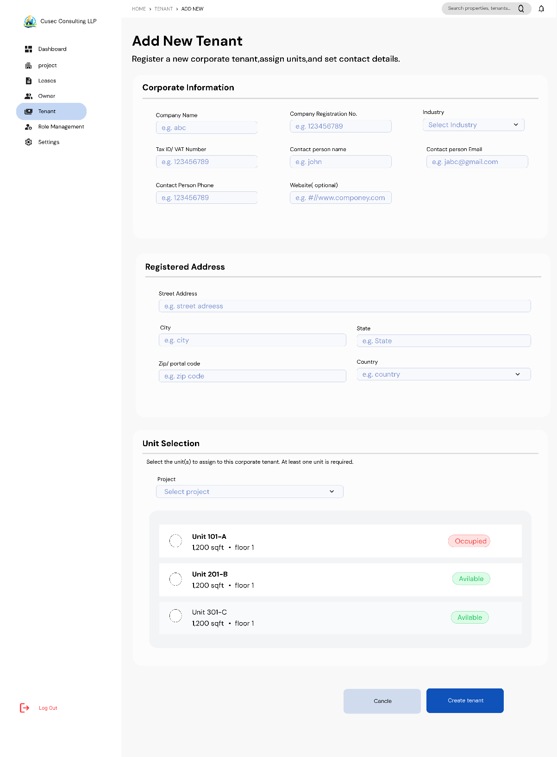
- Occupied units will not be shown here or we have to put some logic for future date

Page 15

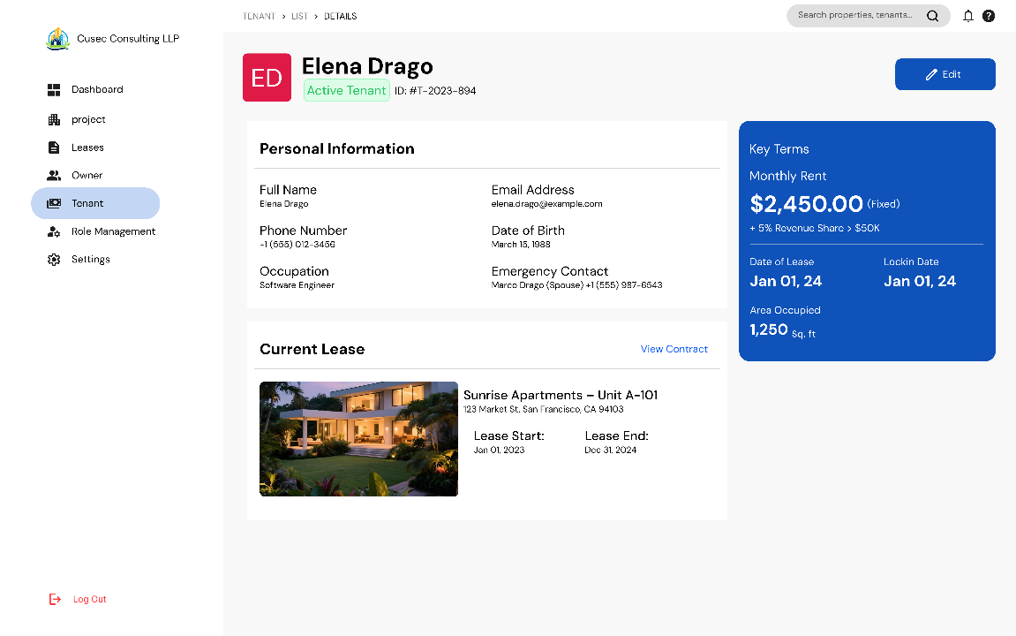
- Date of Birth is not required
- Replace Occupation with Industry
Page 16
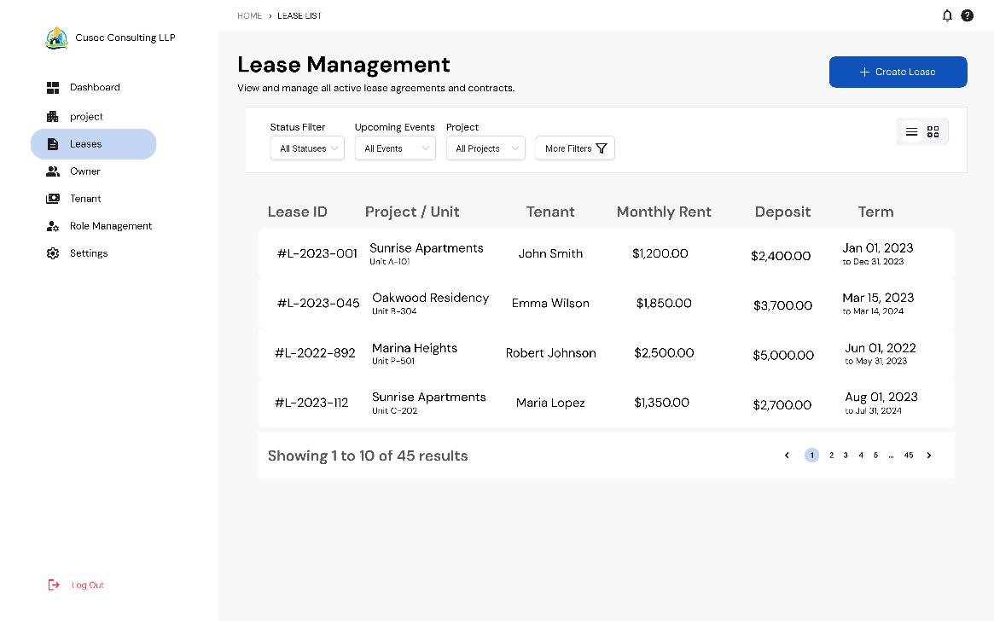

Page 17
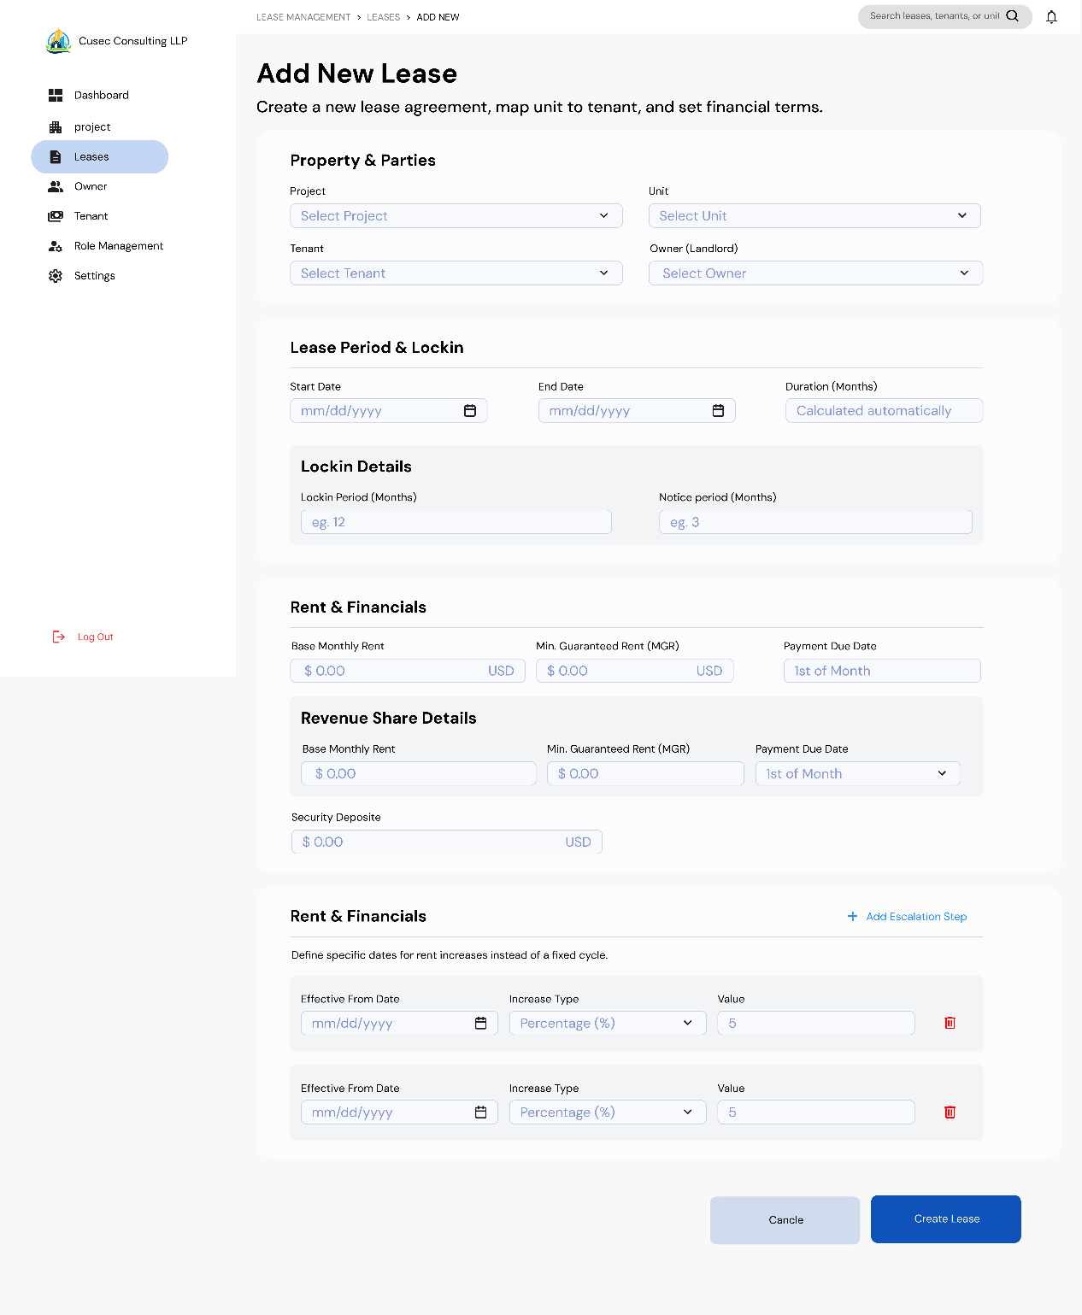
- In the Revenue share model replace base rent with Minimum Guarantee
- This whole section need some modifications, lets discuss
- Option for Fixed Rent or Revenue Share
- Select Fixed Rent
  - Fixed Rent
  - Security Deposit
  - Payment Due date
- Select Revenue Share
  - Minimum Guarantee
  - Revenue Share %
  - Security Deposit
  - Payment Due Date
- For Sub Lease cases all the information remain same except-
  - Tenant becomes Sub tenant and accordingly the information is changed
  - Owner replaced with Tenant
  - No revenue share concept for Sublease
  - Add area in the Sub Lease segment to ensure part of units sub lease

Page 18
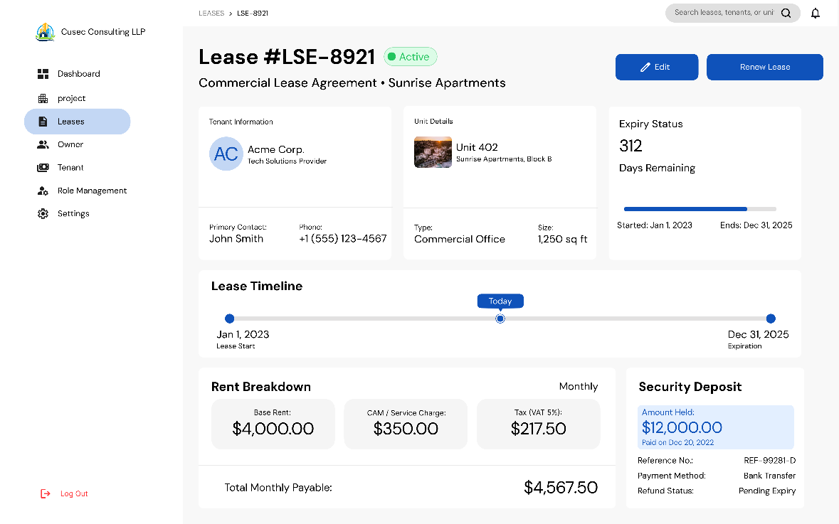
Page 19
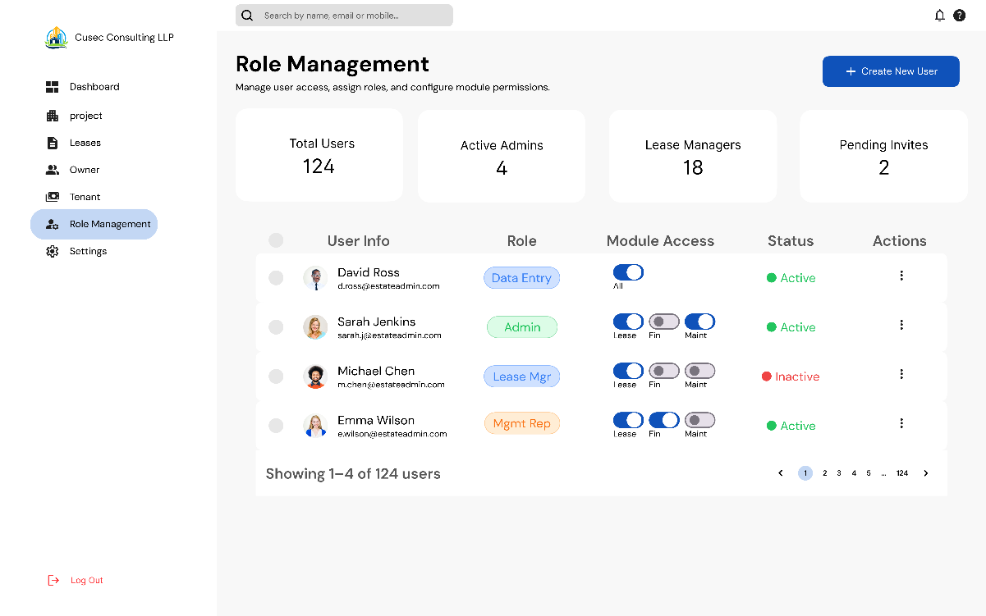

Page 20
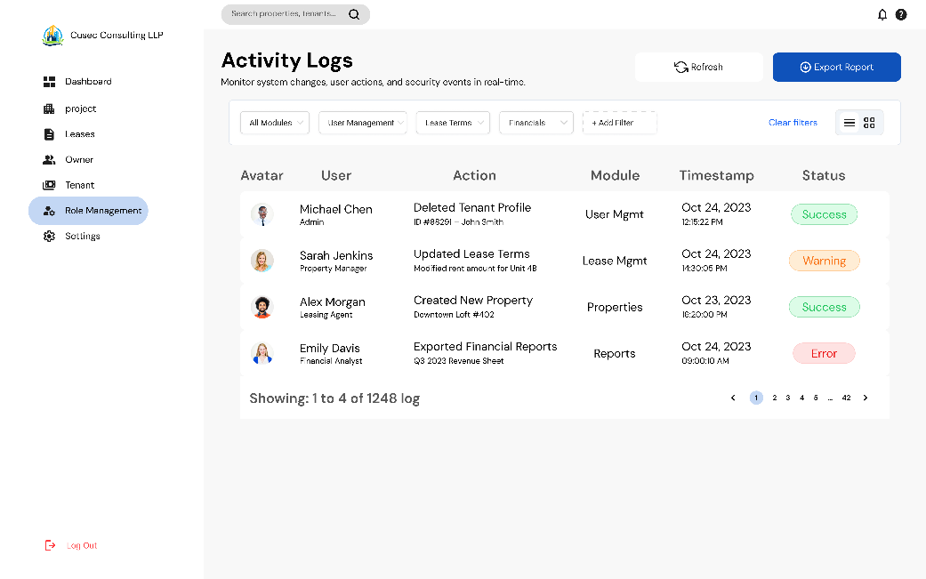
Page 21
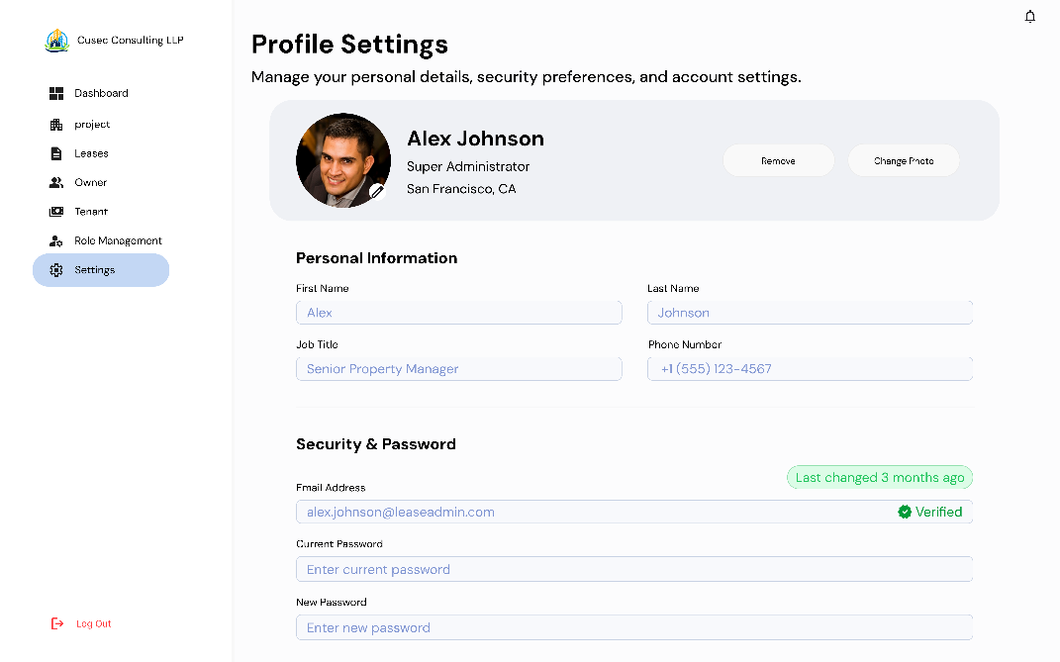

Page 22
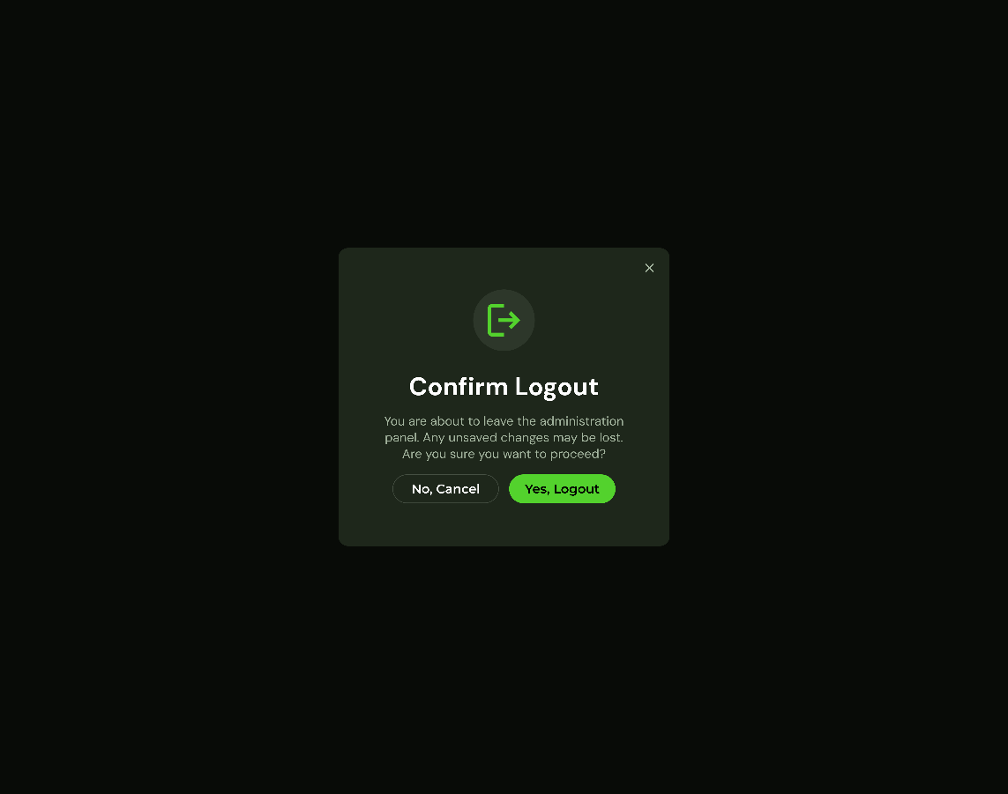
Page 23
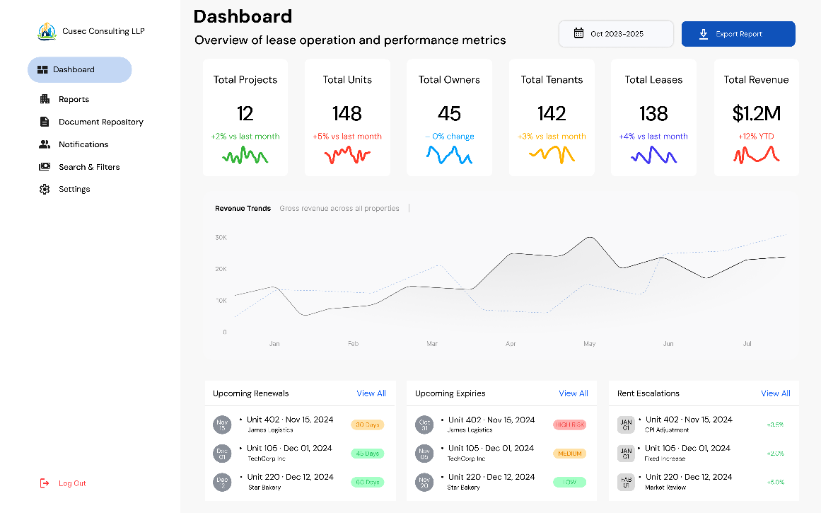

Page24
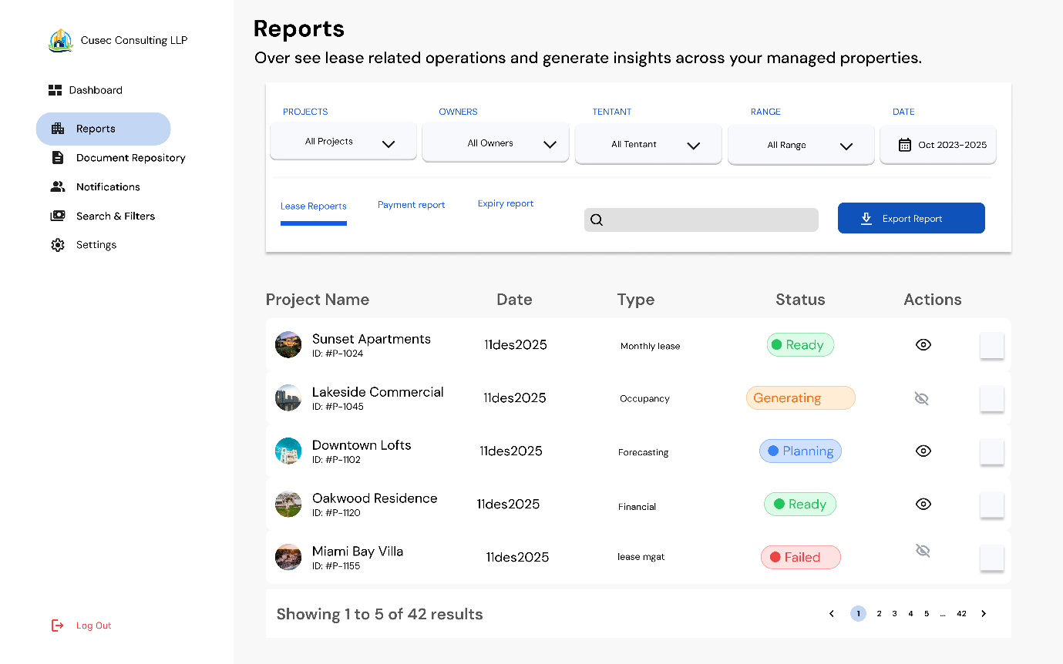
Page 25
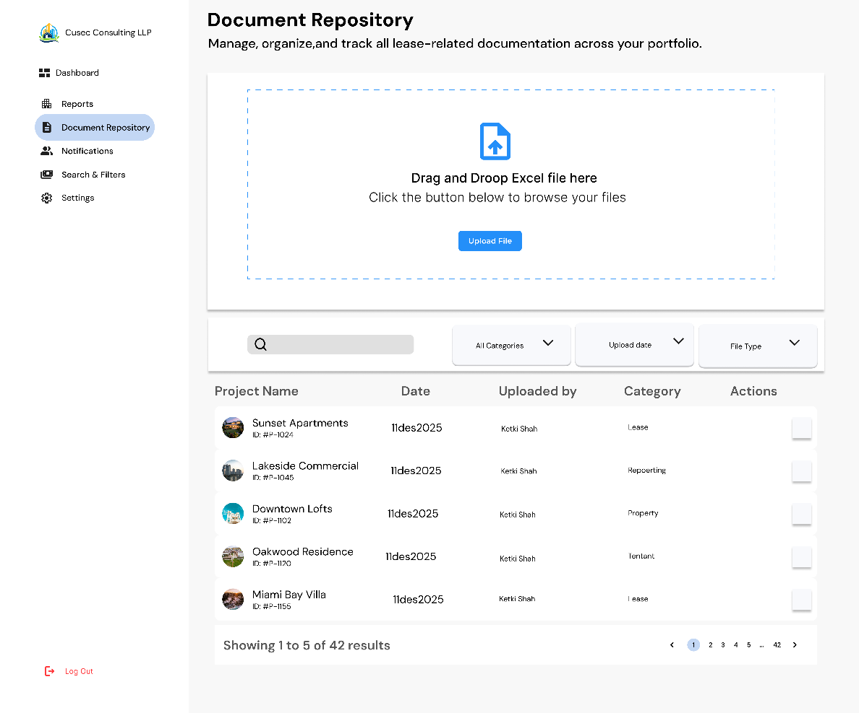
Page 26
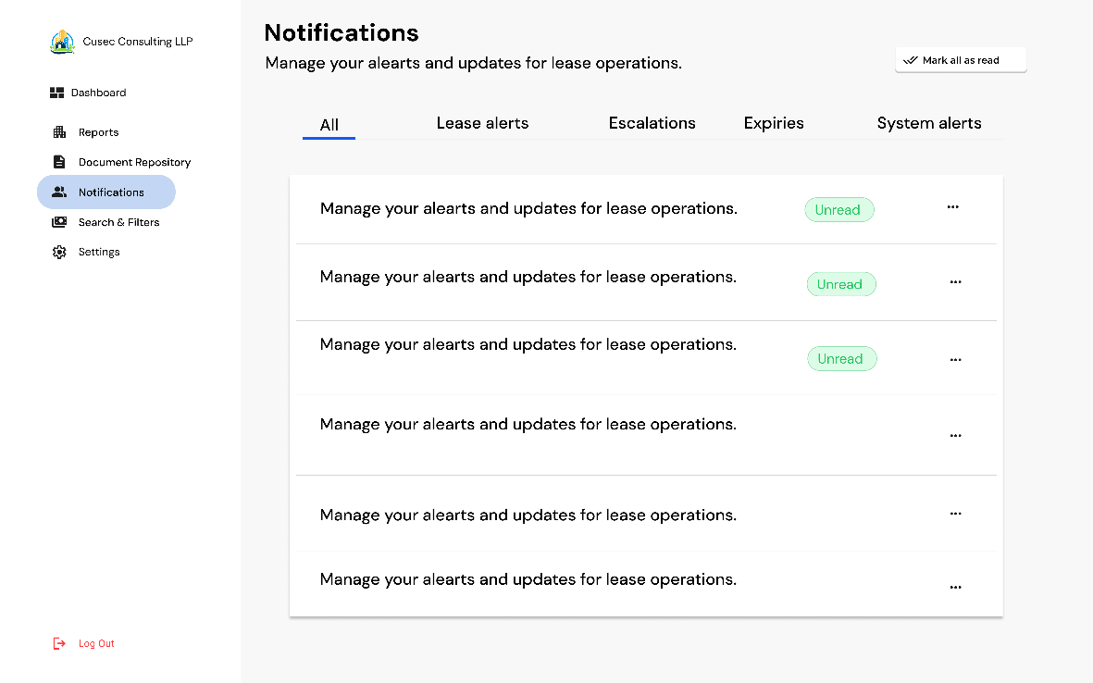
Page 27
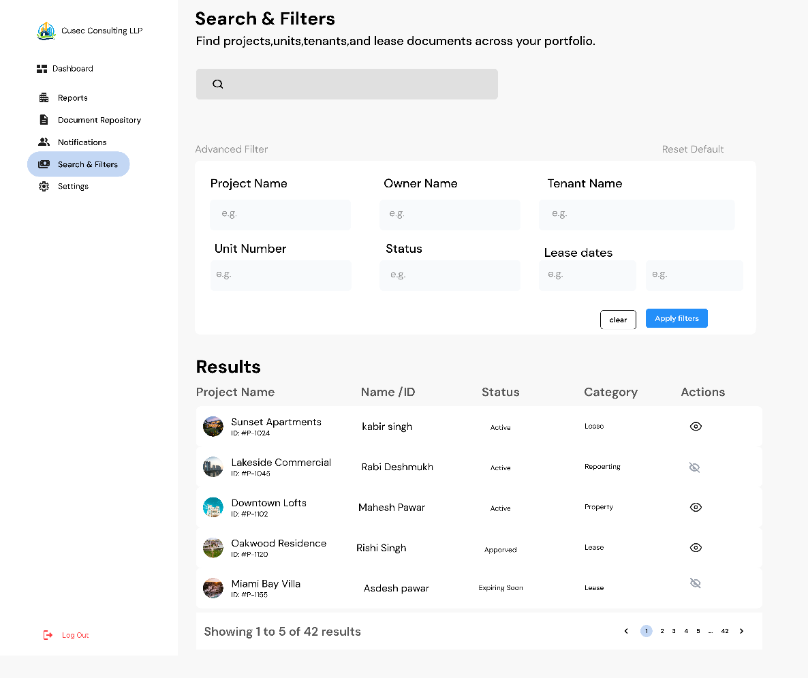

Page 28
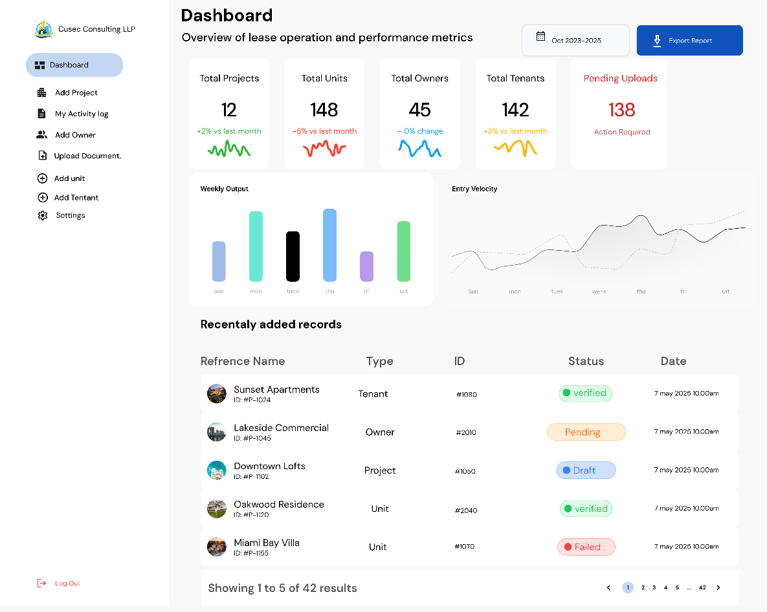
Page 29
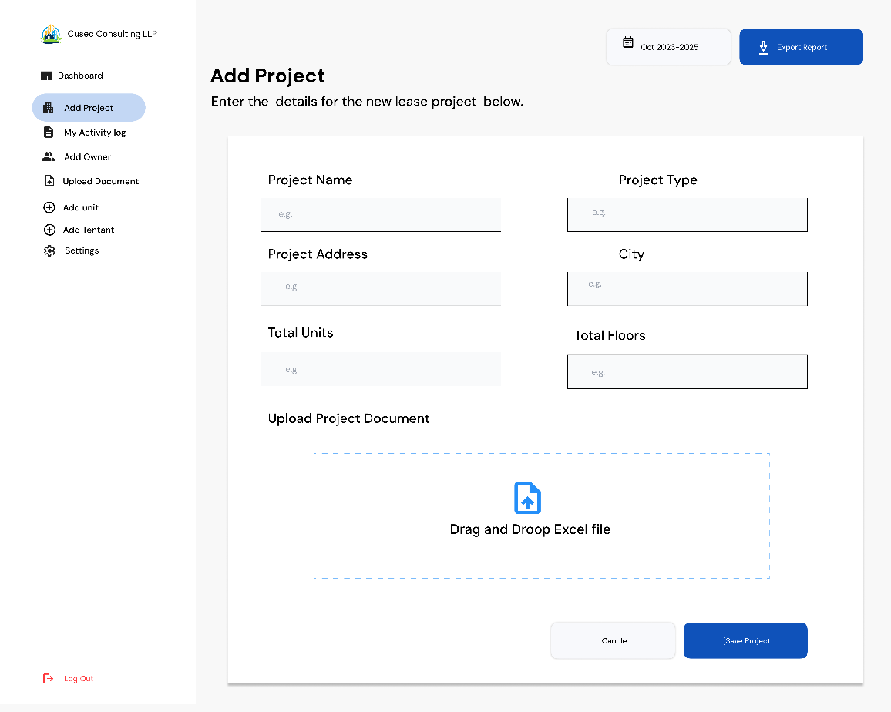
Page 30
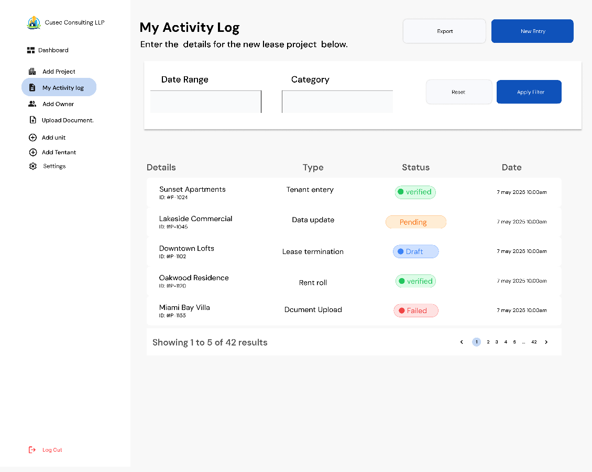
Page 31
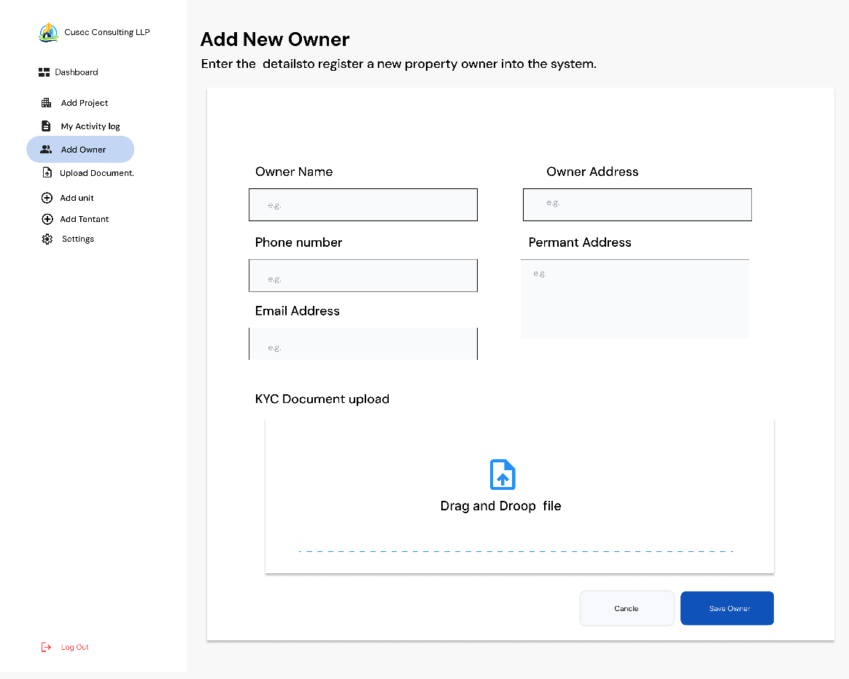

Page 32
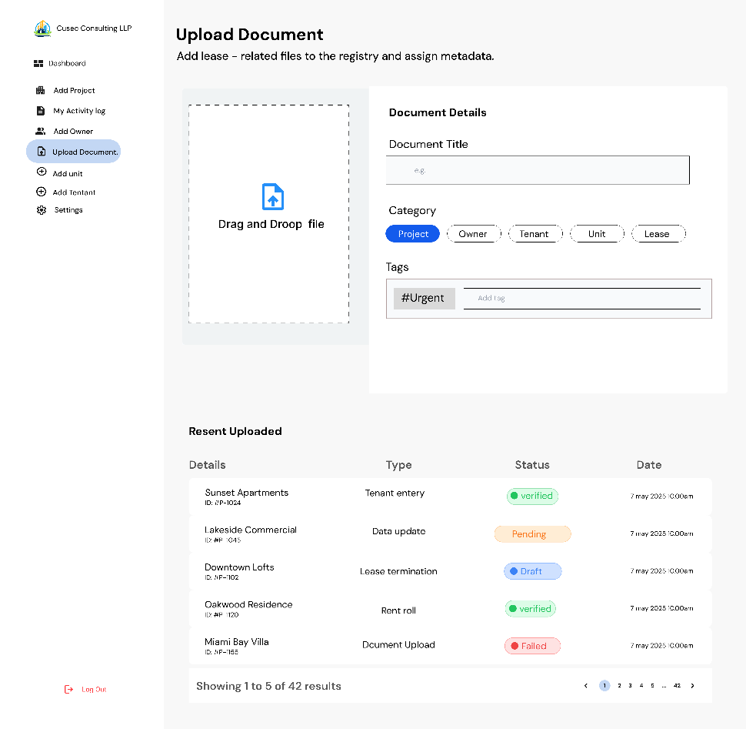
Page 33
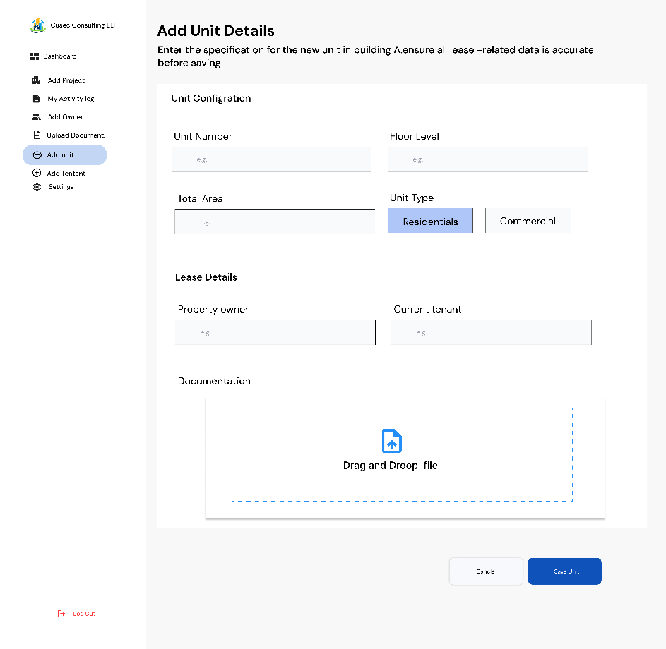
Page 34
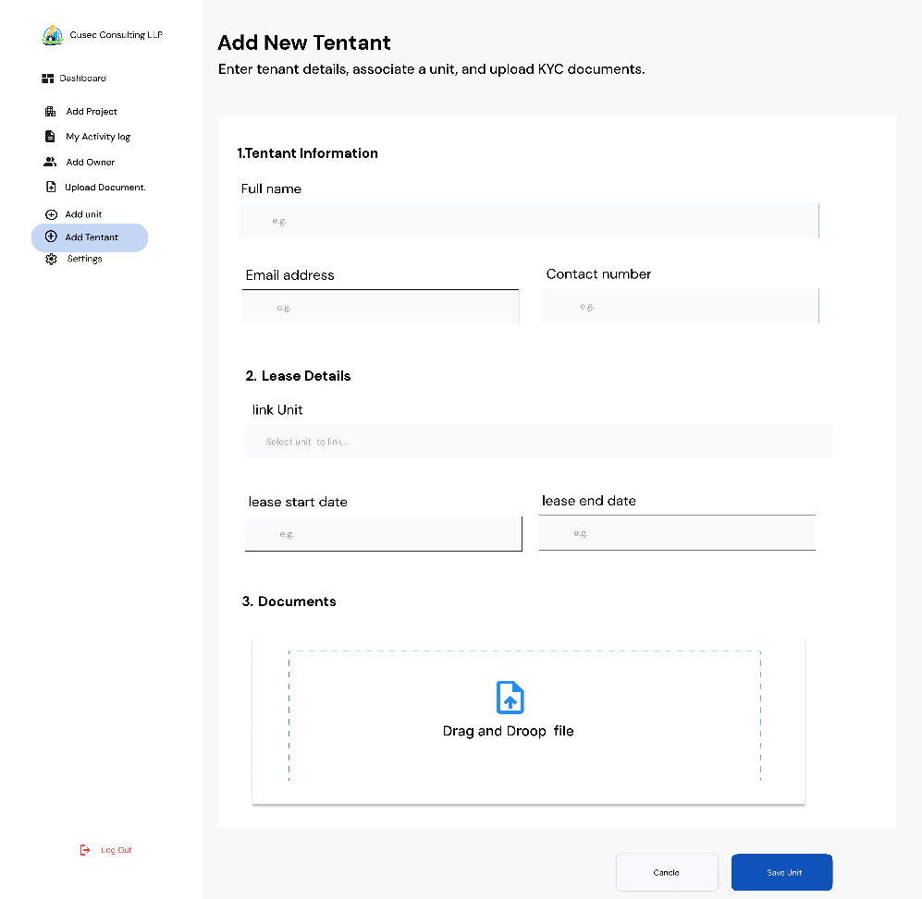
Page 35
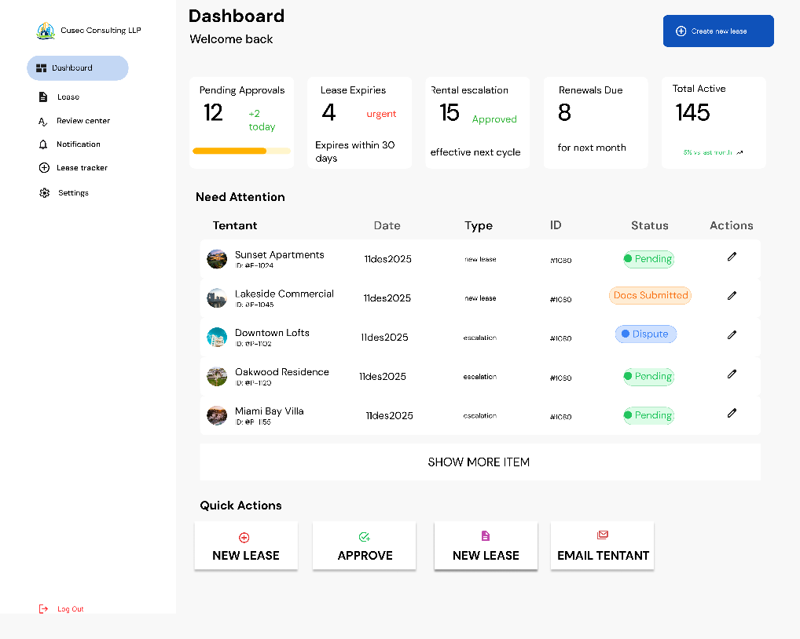

Page 36
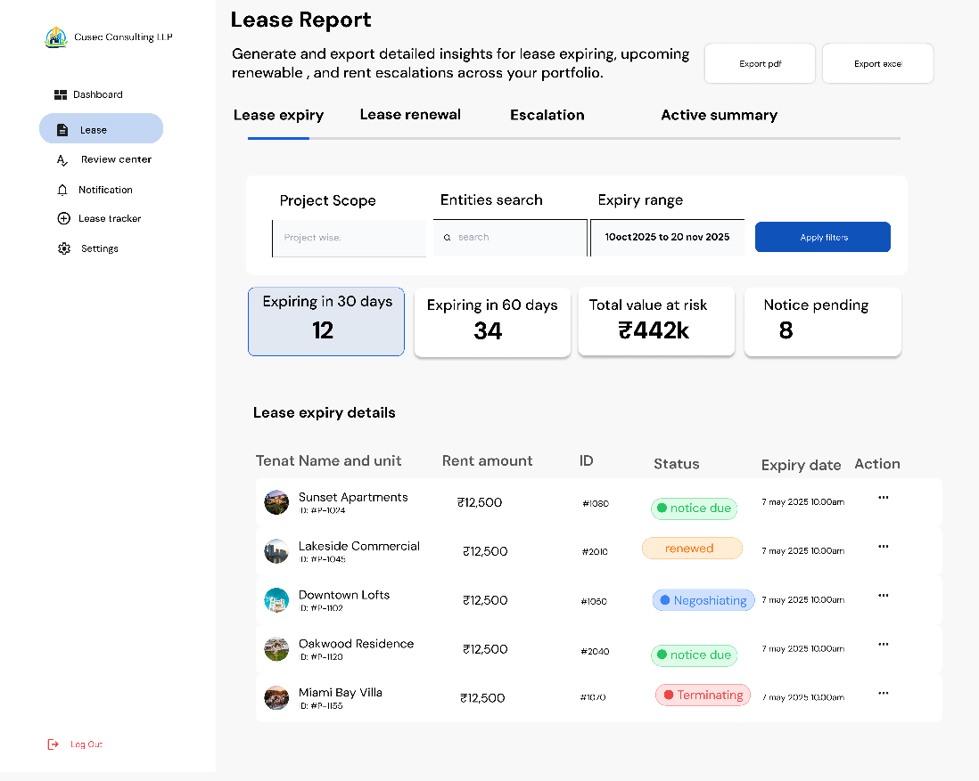
Page 37
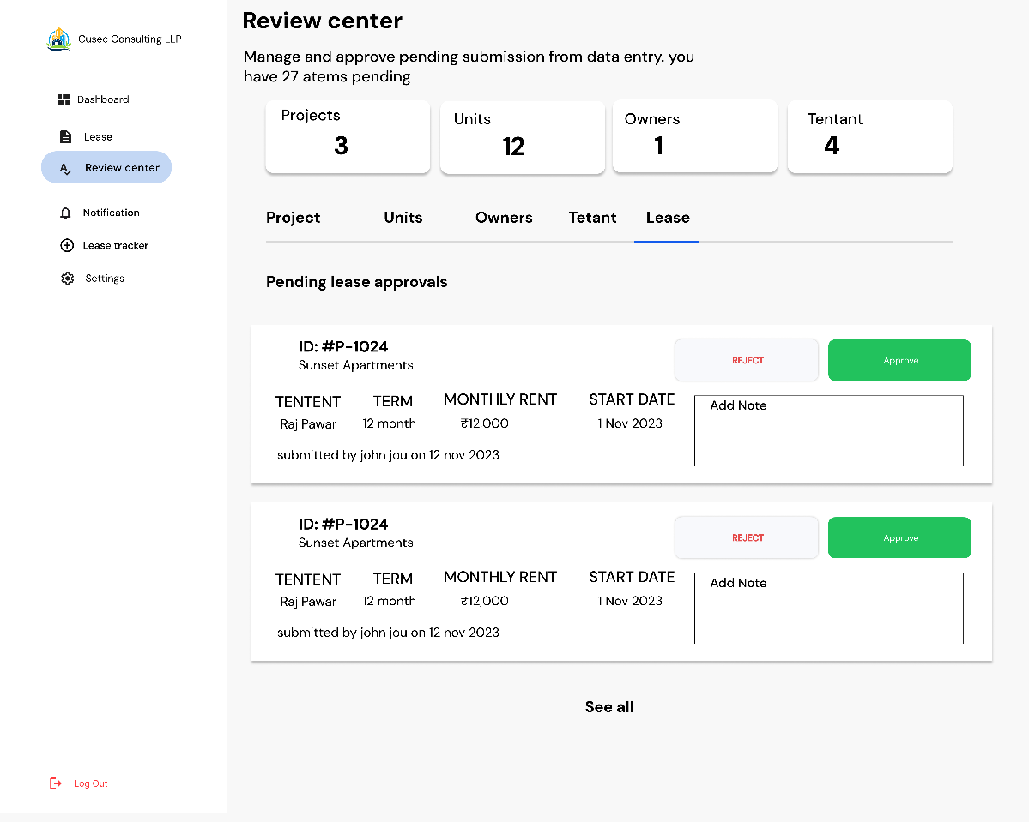

Page 38
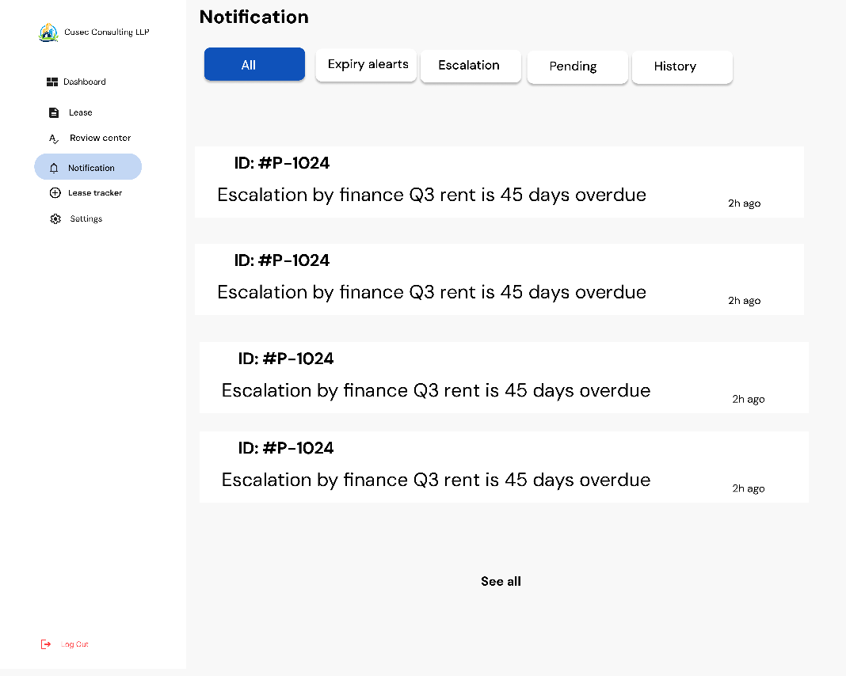
Page 39
